Вариант 4 экзамена по английскому языку в формате ГИА
Общие пояснения к предлагаемым вариантам экзаменационной работы и инструкция по их выполнению изложены в первой статье «Вариант 1...».

Раздел 1. Аудирование
Вы услышите 5 высказываний. Установите соответствие между высказываниями каждого говорящего 1-5 и утверждениями, данными в списке A-F. Используйте каждое утверждение, обозначенное соответствующей буквой, только один раз. В задании есть одно лишнее утверждение. Вы услышите запись дважды. Занесите свои ответы в таблицу.
В1
The speaker talks about
A. good strategies to initiate a conversation with anybody.
B. a good strategy how to hide your natural shyness.
C. a good strategy for keeping a conversation going.
D. some preparations before a conversation.
E. a good strategy how to take an interview.
F. the language that doesn’t need words.

Говорящий | 1 | 2 | 3 | 4 | 5
Утверждение (буква)

Вы услышите разговор ведущего радиопрограммы и директора агентства по здравоохранению. Определите, какие из приведённых утверждений А1-А4 соответствуют содержанию текста (1 — True), какие не соответствуют (2 — False) и о чём в тексте не сказано, то есть на основании текста нельзя дать ни положительного, ни отрицательного ответа (3 — Not stated). Обведите номер выбранного вами варианта ответа. Вы услышите запись дважды.
А1 Artemisinin is a drug for malaria.
1) True 2) False 3) Not stated
А2 Artemisinin is most effective when used with other anti-malaria drugs.
1) True 2) False 3) Not stated
A3 he World Health Organization made it impossible to sell artemisinin as a monotherapy.
1) True 2) False 3) Not stated
А4 Traditional Chinese medicine uses the sweet wormwood to cure different diseases.
1) True 2) False 3) Not stated

Раздел 2. Чтение
Прочитайте информацию для студентов, только что приехавших в летнюю школу. Установите соответствие между заголовками A-Fи пронумерованными абзацами текста 1-5. Запишите свои ответы в таблицу. Используйте каждую букву только один раз. В задании есть один лишний заголовок.
B2
A. Was it easy to get to the areas where spices grew?
B. Who had exclusive rights for pepper trade?
C. What proves that spices in old times were even more used than today?
D. Where did rare spices come from?
E. Merchants from what place were number one in pepper trade?
F. What was special about use of spices in old times??
1. Pepper, the most common and at the same time the most valued of spices, was frequently treated as a gift of honor from one sovereign to another, or as a polite form of payment instead of money. «Matilda de Chaucer is in the gift of the king, and her land is worth 8 pounds, 2d, and 1 pound of pepper and 1 pound of cinnamon and 1 ounce of silk,» reads a chance record in an old English survey.
2. The amount of these spices bought and sold was astonishing even as compared to modern trade. Venetian galleys, Genoese carracks, and other vessels on the Mediterranean brought great amount of them westward, and they were sold in fairs and markets everywhere. In romances and chronicles, in cook-books, trades-lists, and customs-tariffs, spices are mentioned with a frequency and consideration unknown in modern times.
3. For years the Venetians had a contract to buy from the sultan of Egypt annually 420,000 pounds of pepper. One of the first vessels to make its way to India brought home 210,000 pounds. A fine of 200,000 pounds of pepper was imposed upon one prince of India who refused to sell pepper to the Portuguese in 1520. «Pepper-sack» was a nick-name and yet not a negative epithet applied by German robbers, to Venetians merchants who passed down the Rhine.
4. Yet the location of «the isles where the spices grow» was very distant and obscure to the men of the Middle Ages. John Cabot, in 1497, said that he «was once at Mecca, whither the spices are brought by caravans from distant countries, and having inquired from whence they were brought and where they grew, the merchants answered that they did not know, but that such merchandise was brought from distant countries by other caravans to their home; and they further say that they are also conveyed from other remote regions».
5. Such lack of knowledge was pardonable, that even Marco Polo, one of the. most experienced travelers, after spending years in Asia, believed, mistakenly, that such rare spices as nutmegs and cloves were produced in Java. It was only after many, many years that their true place of production became known in Europe. These spices were the native products of the so called Spice Islands, just under the equator, in the midst of the Malay Archipelago. Their light, volcanic soil, could keep moist by the constant damp winds.

1 | 2 | 3 | 4 | 5

Прочитайте текст. Определите, какие из приведенных утверждений A5-A8 соответствуют содержанию текста (1 — True), какие не соответствуют (2 — False) и о чем в тексте не сказано, то есть на основании текста нельзя дать ни положительного, ни отрицательного ответа (3 — Not stated).
Every nation and country has a reputation of some kind. The Englishmen are believed to be cold, reserved, rather naughty, easy-going and fond of sport. They are the nation of stay-at- homes. «There is no place like home», they say. The English man’s home is his castle is a saying known all over the world.
They prefer a small house built for one family, with a small garden and a fire in the centre of the house. They like animals very much and follow many traditions especially concerning food and manners. We know much about English traditions and Customs but now I’d like to say a few words about the traditions of my native land-Russia.
First, some words about Russian people. To my mind, the main traits of their characters are their hospitality, their «open heartedness» and inventiveness. Russian fairytales reflect this. Our people are hardworking, patient, never loosing hope for better life. The Russians are the talented nation. Russia gave the world thousands of the world famous writers, composers, scientists, inventors and explorers. All of them are the pride of the nation.
Such names of Gzhel and Khokhloma are considered to be the symbols of Russia as well as matryoshkas and samovars. The history of Khokhloma goes back to the 17th century. The production of tableware-dishes, spoons, mugs was begun at that time in the villages of Suomino and Khokhloma in the Nizhniy Novgorod Province. Many carpenters, painters have been working since then reviving traditions of old masters.
The Khokhloma style is characterized by using plant elements in painting the tableware. The prevailing colors are black, yellow, golden, green and red.
Nowadays this craft is sure to be saved; it will be developed and brought into the future by the new generation of painters.
A5 The Englishmen have bad reputation among different nations in the world.
1) True 2) False 3) Not stated
A6 English people are home-centered.
1) True 2) False 3) Not stated
A7 Russia has contributed a lot to the world civilization.
1) True 2) False 3) Not stated
A8 Khokhloma style has been a typical Russian craft since Kievan Russ.
1) True 2) False 3) Not stated

Раздел 3. Грамматика и лексика
Прочитайте текст. Преобразуйте слова, напечатанные заглавными буквами в конце строк, обозначенных номерами ВЗ-В9 так, чтобы они грамматически соответствовали содержанию текста. Заполните пропуски полученными словами. Каждый пропуск соответствует отдельному заданию ВЗ-В9.
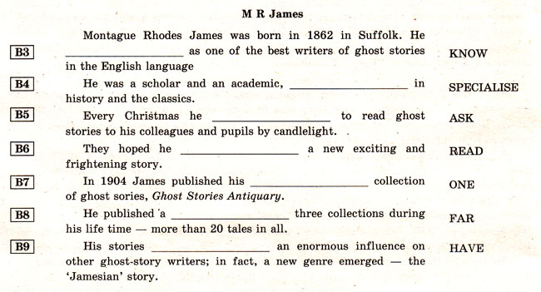
Прочитайте текст. Преобразуйте слова, напечатанные заглавными буквами в конце строк, обозначенных номерами В10-В14 так, чтобы они грамматически и лексически соответствовали содержанию текста. Заполните пропуски полученными словами. Каждый пропуск соответствует отдельному заданию В10-В14.
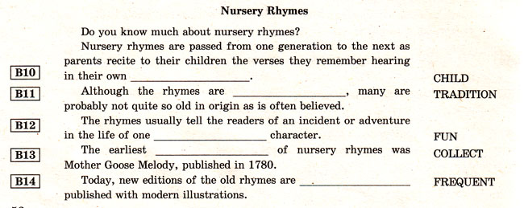

Раздел 4. Письмо
Для ответа на задание С1 используйте отдельный чистый лист.
При выполнении задания С1 особое внимание обратите на то, что ваши ответы будут оцениваться только по записям, сделанным на отдельном листе. Никакие записи черновика не будут учитываться экспертом.
Обратите внимание на необходимость соблюдения указанного объёма письма. Письма недостаточного объема, а также часть текста письма, превышающая требуемый объем — не оцениваются.
На чистом листе вы указываете сначала номер задания С1, а потом пишете свой ответ.
С1
You have 30 minutes to do this task.
You have received a letter from your English-speaking pen friend Lucy.
... I am going to do a project on national holidays of different countries. Could you help me? What main national holidays are there in your country? Do you celebrate all of them? How does your family celebrate them?
Write h’im a letter and answer his 3 questions.
Write 80–100 words. Remember the rules of letter writing.

Раздел 5. Говорение
Вы получите карточку, на которой представлены два задания для устного ответа: С2 — тематическое монологическое высказывание, СЗ — диалог-расспрос. Окончание выполнения каждого задания определяет экзаменатор. Во время проведения этой части экзамена идёт постоянная запись вашего ответа.
Задания для экзаменуемого
