Вариант 5 экзамена по английскому языку в формате ГИА
Общие пояснения к предлагаемым вариантам экзаменационной работы и инструкция по их выполнению изложены в первой статье «Вариант 1...».

Раздел 1. Аудирование
Вы услышите 5 высказываний. Установите соответствие между высказываниями каждого говорящего 1-5 и утверждениями, данными в списке A-F.Используйте каждое утверждение, обозначенное соответствующей буквой, только один раз. В задании есть одно лишнее утверждение.Вы услышите запись дважды. Занесите свои ответы в таблицу.
В1
A. Human activities do not benefit nature.
B. To save animals save their habitats.
C. Pollution now is dangerous
D. Set to protect wild life
E. Aware of the danger.
F. Killed for the sake of people’s needs

Говорящий | 1 | 2 | 3 | 4 | 5
Утверждение (буква)

Вы услышите беседу корреспондента радио и преподавателя страноведения США одного из американских колледжей. Определите, какие из приведённых утверждений. А1-А4 соответствуют содержанию текста (1 — True), какие не соответствуют (2 — False) и о чём в тексте не сказано, то есть на основании текста нельзя датНь ни положительного, ни отрицательного ответа (3 — Not stated). Обведите номер выбранного вами варианта ответа. Вы услышите запись дважды.
А1 Mrs. Jackson finds American Indians’ culture most interesting.
1) True 2) False 3) Not stated
A2 Indians culture was studied by Shakespeare.
1) True 2) False 3) Not stated
A3 Both the reporter and the lecturer agree that children all over the world like to play Indians.
1) True 2) False 3) Not stated
A4 Indians know how to adapt traditional culture to modern environment.
1) True 2) False 3) Not stated

Раздел 2. Чтение
Прочитайте информацию для студентов, только что приехавших в летнюю школу. Установите соответствие между заголовками A-F и пронумерованными абзацами текста 1-5. Запишите свои ответы в таблицу. Используйте каждую букву только один раз. В задании есть один лишний заголовок.
B2
A. There are lots of achievements to proud of.
B. Different actions were taken for one reason.
C. A lot of time was lost in protecting nature.
D. Nature protection has to struggle against industries.
E. The two aimed to help wildlife.
F. There was no time to lose.
1. More than a hundred years ago, two men who barely knew each other climbed up into the Sierra Nevada wilderness and spent four days exploring mountains and tracking wildlife. They saw elk and black bear, wild iris and larkspur. They drank from streams, slept on beds of pine needles, and awoke from a night camping on Glacier point to find four feet of sunrise snow. When they came down from the mountains, President Theodor Roosevelt and Sierra Club founder John Muir were good friends. Over their parting handshake they made a pact: They would work together to save America’s wilderness. And they did.
2. The United States had already lost most of its buffalo, tallgrass prairies, Eastern old-growth forests, and grizzly bears. Bold, immediate action was called for—and taken. Between 1901 and 1909, President Roosevelt and Congress created five national parks, established more than fifty wildlife reserves, and set aside 100 million acres of forest for protection. During the decade, the Sierra Club grew from a hiking club to a political force.
3. John Muir and the growing membership of his Sierra Club conducted guided tours to wild areas to win allies and public support for the preservation efforts, wrote letters and articles in newspapers, pioneered the use of public education, political accountability and lobbing, and legislation to protect the health of our environment. It was the Sierra Club that fled lawsuits to stop pollution in Lake Superior and developments in Everglades, and created books, films, photographs, and advertising for wilderness and wildlife protection.
4. Since its founding in 1892, the Sierra Club has also helped bring about the establishment of Yosemite and more than a score of other national parks; an end to government plans to dam the Colorado River and flood the Grand Canyon; the enactment of the Clean Water Act, Clean Air Act, and Endangered Species Act; the granting of national movement status for Utah’s Grand Staircase — Escalante, the giant sequoias of California’s Serra Nevada and many more national treasures in different parts of the country, including Alaska.
5. More than a century of national and local conservation campaigns has taught the Sierra Club that no place—despite its official designation, environmental value, or storied past—is ever completely protected. The oil companies, the logging industry, and developers never give up. And as the nation grows, the pressures to drill, log, and build in special places will also grow.

1 | 2 | 3 | 4 | 5

Прочитайте текст. Определите, какие из приведенных утверждений A5-A8 соответствуют содержанию текста (1 — True), какие не соответствуют (2 — False) и о чем в тексте не сказано, то есть на основании текста нельзя дать ни положительного, ни отрицательного ответа (3 — Not stated).
Jim lived with his parents until he was twenty-one years old, and then he got a job in the office of a big factory in another town, so he left home. He found a comfortable little flat which had two rooms, a small kitchen and a bathroom, and he lived there on his own.
At first he cleaned it himself, but he did not like it, so he determined to find someone else to do it instead of him. He asked a lot of his fellow workers at the factory what they did about this, and at last one of the men said, «Oh, Mrs. Roper comes and cleans my flat regularly. She washes the dishes, irons my shirts and keeps the place neat and tidy and so on. I’ll introduce her to you, if you like. She’s a charming old lady. She does her best, but she hasn’t got much energy».
«Well, you’d better ask her to come and see me, please,» Jim answered. So the next evening Mrs. Roper came to see him, and she agreed to come to his flat every morning for an hour.
After she had been working for Jim for two weeks, he looked at the mirror in his bedroom and thought, «That mirror looks very dusty. Mrs. Roper’s forgotten to clean it. I can write on it with my finger.» He wrote a message in the dust: «I’m coughing whenever I breathe because everything in this room is very dusty.»
He came home at 7 o’clock that evening, and when he had eaten his supper, he went into his bedroom and looked at the mirror. «That silly woman still hasn’t cleaned it!» he said to himself. «All it needs is a cloth!»
But then he bent down and saw a bottle in front of the mirror. «I didn’t put that bottle there,» he thought. «Mrs. Roper must have left it.» He picked the bottle up and looked at it carefully.
«She’s written some words on it», he said to himself. He read the words. They were: «Cough-medicine».
A5 Jim left home city to continue his education.
1) True 2) False 3) Not stated
A6 Jim could not clean his house because he was allergic to dust.
1) True 2) False 3) Not stated
A7 Mrs. Roper did not have enough time to dust the room.
1) True 2) False 3) Not stated
A8 Jim was not happy with Mrs. Roper as a cleaner.
1) True 2) False 3) Not stated

Раздел 3. Грамматика и лексика
Прочитайте текст. Преобразуйте слова, напечатанные заглавными буквами в конце строк, обозначенных номерами ВЗ-В9 так, чтобы они грамматически соответствовали содержанию текста. Заполните пропуски полученными словами. Каждый пропуск соответствует отдельному заданию ВЗ-В9.
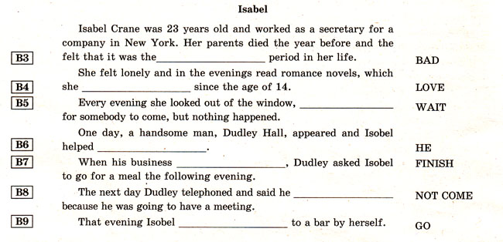
Прочитайте текст. Преобразуйте слова, напечатанные заглавными буквами в конце строк, обозначенных номерами В10-В14 так, чтобы они грамматически и лексически соответствовали содержанию текста. Заполните пропуски полученными словами. Каждый пропуск соответствует отдельному заданию В10-В14.
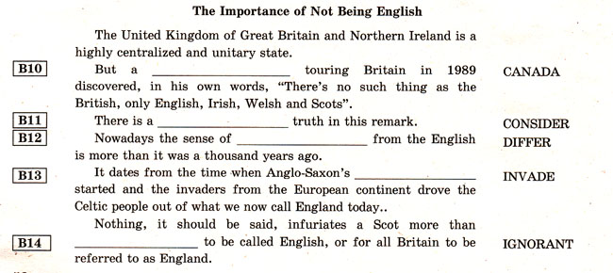

Раздел 4. Письмо
Для ответа на задание С1 используйте отдельный чистый лист.
При выполнении задания С1 особое внимание обратите на то, что ваши ответы будут оцениваться только по записям, сделанным на отдельном листе. Никакие записи черновика не будут учитываться экспертом.
Обратите внимание на необходимость соблюдения указанного объёма письма. Письма недостаточного объема, а также часть текста письма, превышающая требуемый объем — не оцениваются.
На чистом листе вы указываете сначала номер задания С1, а потом пишете свой ответ.
С1
You have 30 minutes to do this task.
You have received a letter from your English-speaking pen friend Liz.
... I am going to learn a second foreign language. My first foreign language is French. What second language do you think I should choose and why? How many languages do you study at school? Are you planning to enter some language courses?
Write him a letter and answer his 3 questions.
Write 80–100 words. Remember the rules of letter writing.

Раздел 5. Говорение
Вы получите карточку, на которой представлены два задания для устного ответа: С2 — тематическое монологическое высказывание, СЗ — диалог-расспрос. Окончание выполнения каждого задания определяет экзаменатор. Во время проведения этой части экзамена идёт постоянная запись вашего ответа.
Задания для экзаменуемого
